OAKLAND AVENUE BAPTIST CHURCH
3265 Oakland Avenue

Catlettsburg, Kentucky 41129
606-739-4124 or 888-544-4034
Visit us on the Web at www.oaklandavenue.org
_____________________________________________________________________________

Nursery schedule for January & February
SUNDAY | WEDNESDAY
January 1st February 5th  9:00 receptionist: Morgan Michel  9:00 nursery: Janet Adkins  10:15 nursery: Becky Vance  extended session: Judy Kruger & Debbie Vicini  6:30 receptionist: Kim Plummer  6:30 nursery: Janet Barker  3 & 4 year olds: Mary Fraley | January 4th  February 1st  Receptionist: Judy Spears  Workers: Kim Plummer  Mission Friends: Jennifer Fyffe & DeeDee Perdue
January 8th & 29th February 12th  9:00 receptionist: Michelle Holcomb  9:00 nursery: Penny Fuller  10:15 nursery: Kay Lemons  extended session: Michelle McCoy & Teresa Salyers  6:30 receptionist: Shelia Lambert  6:30 nursery: Lisa Coleman  3 & 4 year olds: Jay McGranahan | January 11th  February 8th  Receptionist: Jenny Stout  Workers: Michelle McCoy  Mission Friends: Jennifer Fyffe & DeeDee Perdue
January 15th February 19th  9:00 receptionist: Diane Anderson  9:00 nursery: Jennifer Penix  10:15 nursery: Allison Kazee  extended session: Kathy Hicks & Janet Adkins  6:30 receptionist: Cheryl Hicks  6:30 nursery: Jeanette Billups  3 & 4 year olds: Thomas McCoy | January 18th  February 15th  Receptionist: Patty Wechsler  Workers:  Mission Friends: Jennifer Fyffe & DeeDee Perdue
January 22nd February 26th  9:00 receptionist: Jamie Watterson  9:00 nursery: Cadara Shreve  10:00 nursery: Kylie Haywood  extended session: Teresa Childers & Whitney Griffith  6:30 receptionist: Jenny Stout  6:30 nursery: Jack Kazee & Linda Remmele  3 & 4 year olds: Sherri McGranahan | January 25th  February 22nd  Receptionist: Diane Anderson  Workers: Jay McGranahan  Mission Friends: Jennifer Fyffe & DeeDee Perdue


Van Drivers

1/2 – 1/16 – 1/30 - JA Lambert – 739-6958
19 – 1/23 – Jay McGranahan – 322-5881

2/6 - 20 – Jay McGranahan – 922-5881
2/13 - 27 – JA Lambert –
739-6958


LISA DENNISON - 1/1/61
LINDA REMMELE - 1/1/
JOSH GILBERT - 1/2
EMILY ADKINS - 1/5
KRISTEN GRIFFITH – 1/9
JIM LEMONS - 1/11
O.J. MORRIS – 1/12
PATTY WECHSLER - 1/15
TONI LAUHON - 1/19
CONNIE CURNUTTE - 1/21
KAY LEMONS - 1/22
MOLLY ROBBINS – 1/22
NANCY GREENE - 1/22/59
JAMES ALLEN LAMBERT - 1/23
SHARON JO COLE - 1/23
SANDY CLARK – 1/23/61
LISA WALLIN – 1/24/59
NANCY MCDOWELL - 1/26
JANE GILKERSON - 1/26
MARIE HOOD - 1/27
ERNESTINE HICKS - 1/28
KAYLA HOLCOMB - 1/28
CHRISTINA HICKS – 1/29/68
MIKE BLANKENSHIP – 1/30/64
________________________

HAPPY ANNIVERSARY

NANCY & FRED MCDOWELL
1/4/67

JAMES ALLEN & SHELIA LAMBERT
1/14/66
________________________
KATHY HICKS - 2/1
KELLIE LEMONS - 2/3
CONNIE CHANEY – 2/3
ANNA VANCE – 2/4
KATHY WOODS - 2/8/62
ALLISON KAZEE- 2/9/84
MARIE FANNIN - 2/9
MORGAN MICHEL - 2/11/59
DEBRA SHANNON - 2/11
DOTTIE SAYLERS - 2/14
ANN HAMMOND - 2/14/39
BRENDA CHAFFIN – 2/14
MIKE BILLUPS - 2/16
SETH BLANKENSHIP – 2/16
MICHELLE HOLCOMB - 2/17
VANESSA NEIN - 2/18
CAMERON ARTHUR - 2/18
TERESA SALYERS - 2/19
TIM WOODS - 2/20/55
DEBBIE VICINI – 2/23
TORIE WELLMAN – 2/24

HAPPY ANNIVERSARY

NICCI & BRANDON
GIBBS
2/4/2017
___________________

Lottie Moon offering goes through the end of this month. Thank you for giving.
___________________

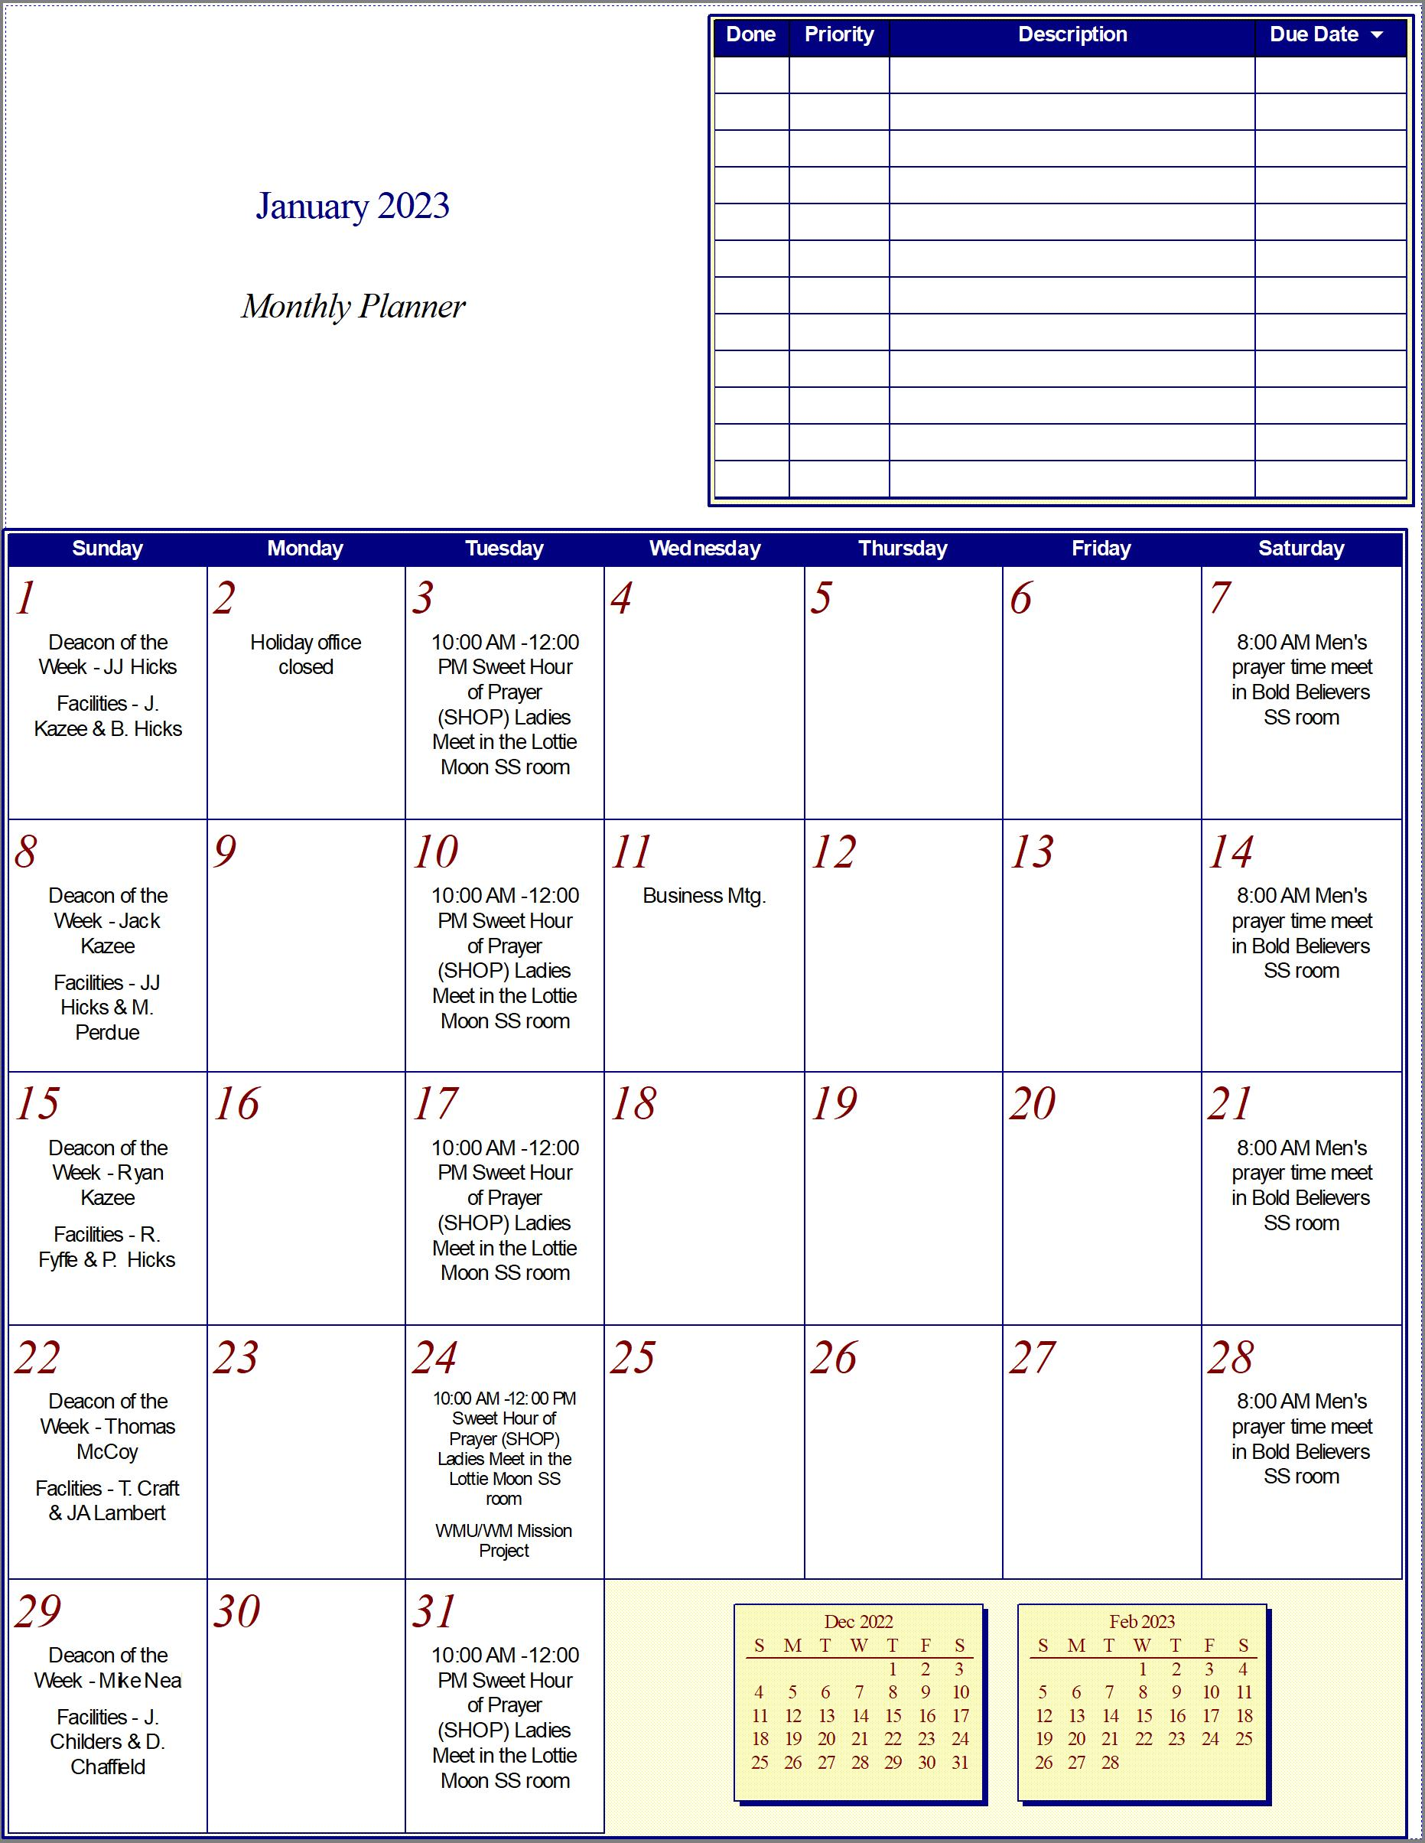
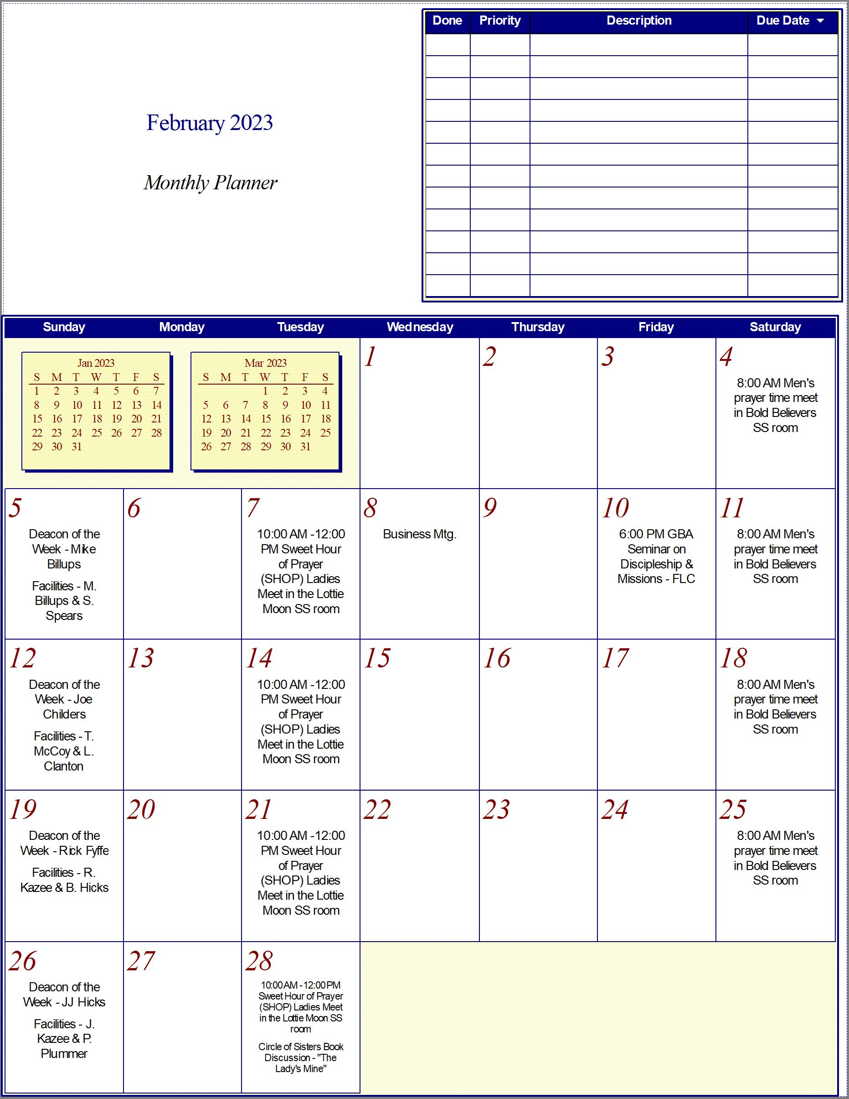

A Note from the Pastor:
I have learned in whatever situation I am to be content. Philippians 4:11

Contentment with what we have is worth far more than all the things we don't have. The person living on the basis of merit is never content. One day he thinks he isn't being rewarded fairly by God; the next day he's afraid he has forfeited all hope for any reward. Far better to adopt the biblical attitude that grace doesn't depend on merit at all, but on the infinite goodness and sovereign purpose of God. I would much rather entrust my expectations of blessings and answers to prayer to the infinite goodness of God and His sovereign purpose for my life than rely on all the merit points I could ever accumulate.
With this emphasis on contentment, I'm not suggesting we should always be satisfied with the status quo in every area of our lives and not pray for or seek improvement. Remember, God by His nature is graciously disposed to give us all good things (Romans 8:32). But for all of us, there are certain things that simply aren't going to change. In those areas, we must learn to be content, always accepting the fact that God doesn't owe us something different.

Bro. Mike
________________________________________________________________________________

OAKLAND AVENUE BAPTIST CHURCH
3265 OAKLAND AVENUE
CATLETTSBURG, KY 41129

Office Hours
M-F 8:00 - 4:30

Call us.
1-888-544-4034 (Toll-Free)
606-739-4124 (Local)

